## Define

Health: Overall measure of physical *and* mental stability.  
Work: Job satisfaction and ability to pay for necessities.  
Play: Entertainment.  
Love: Feeling of appreciation.

## Measure

Health: ¼  
Work: full  
Play: ¾  
Love: 0

## Analysis

Work is excellent and play is mostly adequate. There are obvious problems in the love area which affect health as well, but these appear to unfortunately be outside of my influence; these are gravity problems. It has become apparent to me over the course of several years that I cannot solve these problems and as such, I must simply keep moving forward.

## Summary

I’m physically healthy, and work is going well, but I could use a little loving.

# Workview Reflection

By nature of survival, we must work for food at the bare minimum. This is a common effort between all living creature. Unlike other animals, however, humans have a surplus of food readily available through farming, ranching, and other agricultural techniques. This allows us to engage in activities other than simply food scavenging which may further improve the availability of food. Currency is valuable because it allows trade to occur at a moderated level. We work for money to obtain, at least, food. Jobs are essential because obtaining currency opens many doors to trade for many otherwise unobtainable goods, such as cars and houses, on top of food.

# Lifeview Reflection

I hold a broader perspective in life than most other people. In my opinion, the vast majority of inhabitants in this world are far too focused on mundane problems, objects and goals. Evil exists because people are unwilling and too narrow-minded to let go of physical things and ideas in front of them. They believe that life is a competitive game which favors those who have the bigger house, or the fastest car, or the best mile time, etc. While these are all valid competitive goals, the world was not designed to harbor a fleet of the fastest cars. It can do so, but that’s not it’s purpose. The world was designed for its inhabitants, *humans*. People are the reason the world exists. It makes more sense to me to focus on goodly people while I’m alive rather than clunky machinery. This is due to my belief in a God and a Creator who designed a world to place mankind. In this world, mankind is free to grow their own knowledge and experience as a divine soul at their own pace and will. After our physical bodies die, our soul, knowledge and experience will remain as we reunite with our God and remember all things (both of our life and the existence prior).

# Journal

## Monday

|  |  |  |
| --- | --- | --- |
| **Journal** | **Engagement** | **Energy** |
| Sleep | 6 (Zone) | 3 |
| Minecraft | 5 (Zone) | 5 |
| Died in Minecraft | 10 | 2 |
| FL Studio | 8 (Zone) | 6 |
| Class Work | 10 | 6 |

## Tuesday

|  |  |  |
| --- | --- | --- |
| **Journal** | **Engagement** | **Energy** |
| Sleep | 10 (Zone) | 8 |
| Minecraft | 10 (Zone) | 6 |
| Religion Class | 10 | 8 |
| Work | 10 (Zone) | 6 |
| Phone Call w/ Mom | 10 (Zone) | 7 |
| Introspection | 10 (Zone) | 0 |

I’ve found that most of my energy comes from fulfillment and accomplishment. Specifically, the satisfaction of a plan moving into action brings me the most joy. Be it a task with my job, or a presentation for class, successful results bring me the most joy. On the flip side, a lack of successful results will be the most draining for me.

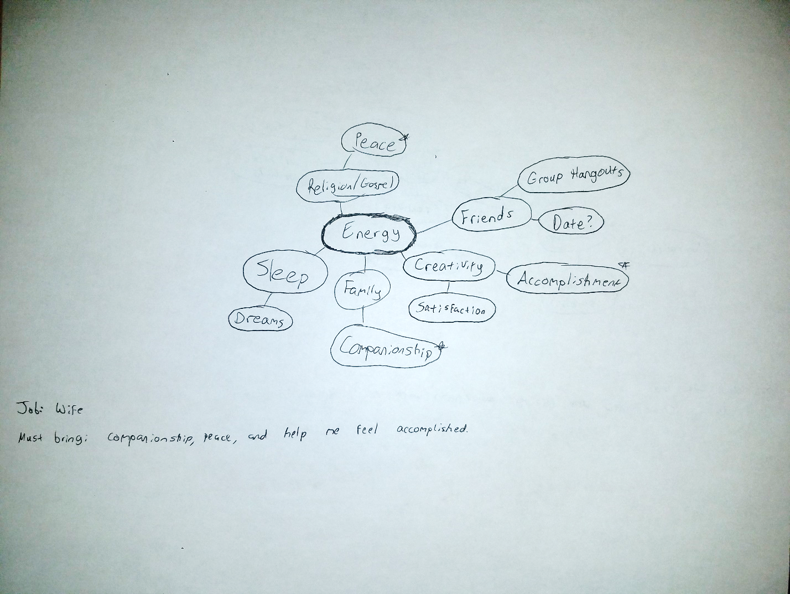

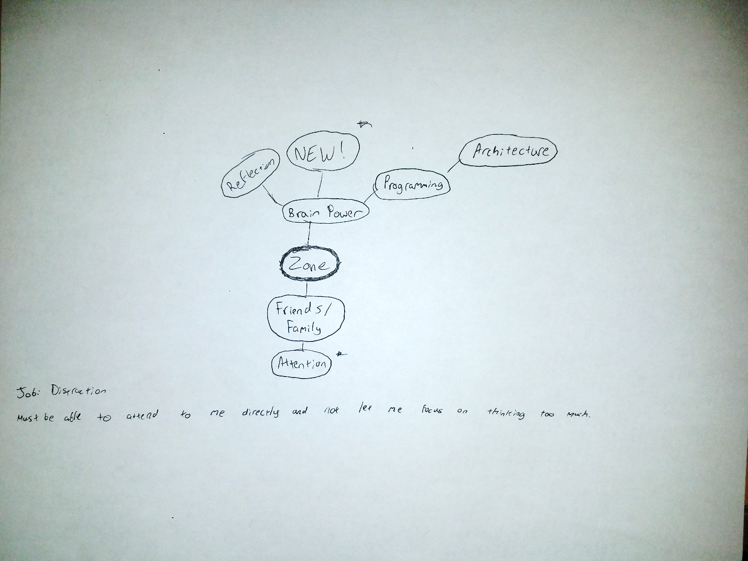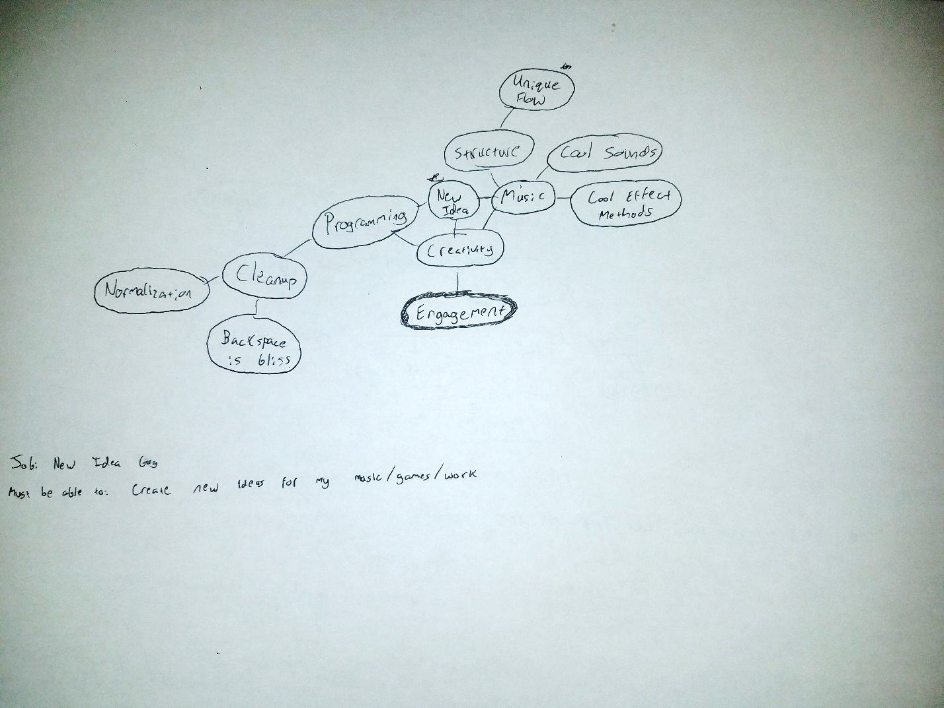

# Odyssey Plan

|  |  |  |  |  |  |
| --- | --- | --- | --- | --- | --- |
| **Year 0** | **Year 1** | **Year 2** | **Year 3** | **Year 4** | **Year 5** |
| Plan A: **Challenging position, long-term reward** | | | | | |
| Continue school | Continue school | Graduate from school | Co-own business with family | Grow enterprise | Continue enterprise |
| Plan B: **Next big-name music artist** | | | | | |
| Change to music major, invest in music production | Continue school. Make a studio? | Graduate from school, make a studio if not already | Produce | Produce more | Produce, consider collabs |
| Plan Unlimited: **Elitist Family** | | | | | |
| Drop out of school, purchase plot of land | Hire architects to design home | Pick best home design, employ construction | Well… now what? Adoption? | Still not enough people to warrant building a school/church… | Tennis court? |

Plan A:

* Questions:
  1. What happens if business goes under?
  2. Will business go big? If so, when?
* Gauges
  1. 90%
  2. Resources: Lots of time; this will be a several-decade endeavor and will require a lot of skill.
  3. Likability: Hot and excited. The idea of owning a successful business is very enticing, especially in the long run.
  4. Confidence: Valid and feasible. Fortunately, the groundwork has mostly been paved already.
  5. Coherence: Makes sense. This will be a grand investment for my family and future generations.

Plan B

* Questions:
  1. Is it possible for me to be a successful producer?
  2. How much am I willing to dump into investment for this?
* Gauges
  1. 30%
  2. Resources: Lots of time, skill (that I don’t currently have) and money. Will need to establish many connections.
  3. Likability: Idea sounds fun, but is risky. If successful, this will produce a lot of accomplishment and revenue. However, that’s *if* successful.
  4. Confidence: Valid but uncertain.
  5. Coherence: Doesn’t match my idea of a long-term investment; only I will benefit from this plan.

Plan C:

* Questions:
  1. Is it possible for me to be a successful producer?
  2. How much am I willing to dump into investment for this?
* Gauges
  1. 0%
  2. Resources: Lots of time, probably more than I will have in my life.
  3. Likability: Like I’m daydreaming. Imagine owning your own plot of land like an elite noble in medieval days.
  4. Confidence: Not happening.
  5. Coherence: This is ideal as it will promote the success of future generations.